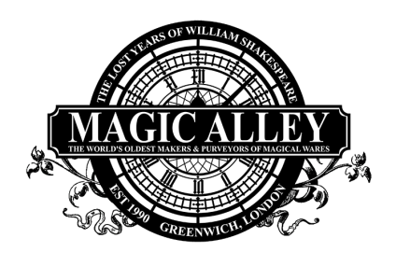
Virtual Tour Quest
Entrance Area
Please click the green tag first and listen to the Introduction
What type of bird is Achimedes?
What is the missing word?
Will’s Study
Answer to Stephens’ riddle
What is the colour of The Other Doctor’s frock coat?
What is the Magic Symbol?
What are the Magic Letters?
Magic School
What type of ink can be seen on the Potion Professor's Desk
Answer to the Potion Professor’s riddle
What is the Magic Symbol?
What are the Magic Letters?
What year was Stonhenge built?
Which book is the Great Wizarding timeline adapted from?

Treasure Vault
Which three jewels make up the ruby necklace?
What is the Magic Symbol?
What are the Magic Letters?
Which card does The Master of Magic make appear in the Treasure Vault in his magic trick?
Tatling &Twaddle
What is the Magic Symbol?
What are the Magic Letters?
Where would the Curious Curator of Clothing be going?
How much does it cost to use the polite telephone box?
Which card does the Master of Magic pin to his jacket?
Magic Alley
Who owns the Apothecary Shop?
What is the Magic Symbol?
What are the Magic Letters?
What is the number of the correct shadow?
How many potion bottles can you see in the apothecary shop window?
Answer to the Master of Magic’s riddle
Valeria’s Study
Answer to Stephens’ riddle
What is the Magic Symbol?
What are the Magic Letters?
What is the name of the skull?
How many parts of Wolfsbane do you need for Valeria's spell?
Downing Street
What is the Magic Symbol?
What are the Magic Letters?
Which three words appear on the tapestry?
Which stately artefact sits on top of the oars?
Which is the odd one out?
What is the phrase on the Royal Crest?
The Map Room
Answer to the Highwayman’s riddle?
What is the Magic Symbol?
What are the Magic Letters?
What does the abbreviation WNS stand for?
Fairy-tale Cottage
What is the Magic Symbol?
What are the Magic Letters?
Answer to the Green Faery’s Riddle?
What are the 10 differences?

The Enchanted Forest
What is the Magic Symbol?
What are the Magic Letters?
Answer to the Treasure Troll’s riddle?
Answer to Lottie and Eunice's riddle?
Take all the magic letters you have found and rearrange them to spell the name of a famous magical villain from a very famous film series
Decode the symbols using the attached cipher (there are 10 symbols to collect)

Now don’t forget to send your answers (in an email is fine or in this answer sheet) to magicalleystratford@gmail.com and if you have done well you will get a certificate bestowing upon you An Introductory Diploma in Wizardry and a voucher for our magical emporium!

A | B | C | D | E | F
 |  |  | ∞
G | H | I | J | K | L
M | N | O | P | Q | R
S | T | U | V | W | X
Y | Z

